**SQL implementation of Project**

**LAB REPORT**



**Spring 2023**

**Data Base Management System Lab**

Submitted by: **Hamza Ali**

Registration No.: **20PWCSE1917**

Class Section: **B**

“On my honor, as student of University of Engineering and Technology, I have neither given nor received unauthorized assistance on this academic work.”

Student Signature: **HamzakhanSwati**

Submitted to:

**Ma’am Sumiyya**

June 5, 2023

Department of Computer Systems Engineering

**University of Engineering and Technology, Peshawar**

***SQL implementation of Project:***

***Lost Found Information System***

***ERD:***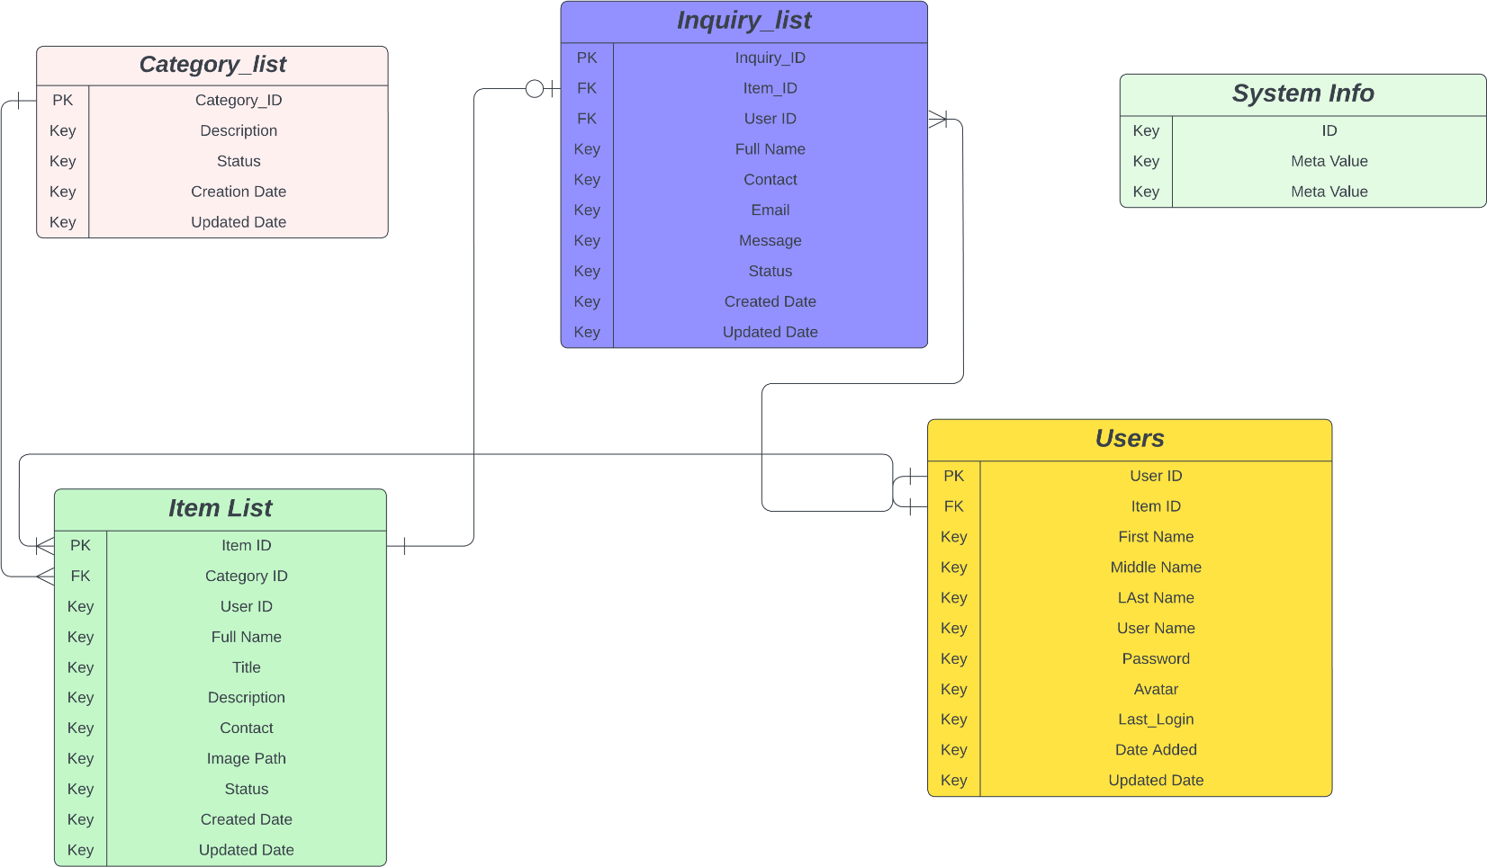

***SQL Queries:***

CREATE TABLE `Category_list` (

`Category_ID` <type>,

`Description` <type>,

`Status` <type>,

`Creation Date` <type>,

`Updated Date` <type>,

PRIMARY KEY (`Category_ID`),

KEY `Key` (`Description`, `Status`, `Creation Date`, `Updated Date`)

);

CREATE TABLE `System Info` (

`ID` <type>,

`Meta Value` <type>,

`Meta Value` <type>,

KEY `Key` (`ID`, `Meta Value`, `Meta Value`)

);

CREATE TABLE `Users` (

`User ID` <type>,

`Item ID` <type>,

`First Name ` <type>,

`Middle Name ` <type>,

`LAst Name` <type>,

`User Name ` <type>,

`Password` <type>,

`Avatar` <type>,

`Last_Login` <type>,

`Date Added` <type>,

`Updated Date` <type>,

PRIMARY KEY (`User ID`),

KEY `Key` (`First Name `, `Middle Name `, `LAst Name`, `User Name `, `Password`, `Avatar`, `Last_Login`, `Date Added`, `Updated Date`)

);

CREATE TABLE `Inquiry_list` (

`Inquiry_ID` <type>,

`Item_ID` <type>,

`User ID` <type>,

`Full Name` <type>,

`Contact` <type>,

`Email` <type>,

`Message` <type>,

`Status` <type>,

`Created Date` <type>,

`Updated Date` <type>,

PRIMARY KEY (`Inquiry_ID`),

FOREIGN KEY (`User ID`) REFERENCES `Users`(`User ID`),

KEY `Key` (`Full Name`, `Contact`, `Email`, `Message`, `Status`, `Created Date`, `Updated Date`)

);

CREATE TABLE `Item List` (

`Item ID` <type>,

`Category ID` <type>,

`User ID` <type>,

`Full Name` <type>,

`Title` <type>,

`Description` <type>,

`Contact` <type>,

`Image Path` <type>,

`Status` <type>,

`Created Date` <type>,

`Updated Date` <type>,

PRIMARY KEY (`Item ID`),

FOREIGN KEY (`Category ID`) REFERENCES `Category_list`(`Category_ID`),

FOREIGN KEY (`Item ID`) REFERENCES `Users`(`Item ID`),

KEY `Key` (`User ID`, `Full Name`, `Title`, `Description`, `Contact`, `Image Path`, `Status`, `Created Date`, `Updated Date`)

);

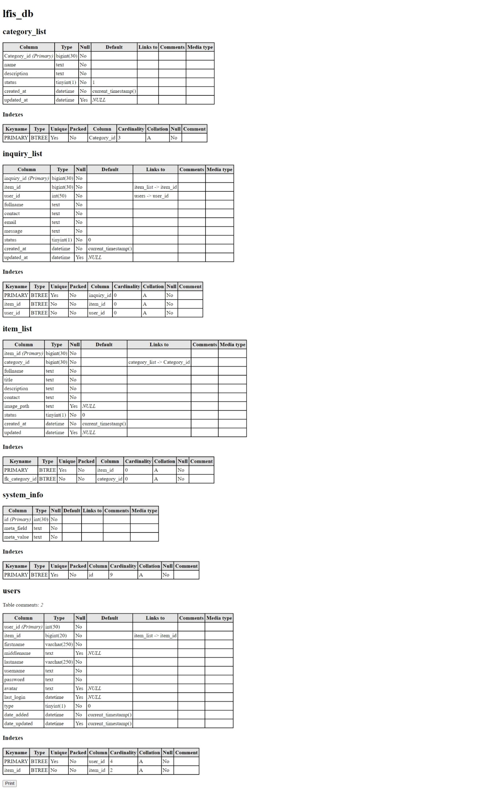***Tables, Metadata & keys:***